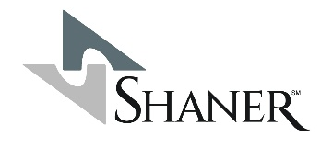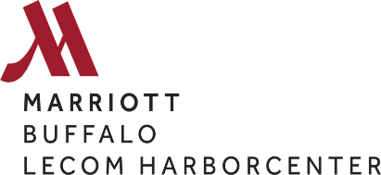

FOR IMMEDIATE RELEASE
June 18, 2026

Huseyin Taran Named Marriott International’s 2025 General Manager of the Year for Premium & Luxury Brands
BUFFALO, N.Y. – Shaner Hotels proudly announces that Huseyin Taran, General Manager of the Buffalo Marriott Lecom Harborcenter, has been named 2025 General Manager of the Year for Premium & Luxury Brands by Marriott International, one of the hospitality industry’s highest honors recognizing exceptional leadership, operational excellence, and commitment to guest satisfaction.
The prestigious award recognizes a select group of hotel leaders across Marriott International’s U.S. & Canada portfolio who consistently deliver outstanding results while exemplifying the company’s values and service standards. Taran was selected for his exceptional leadership of the Buffalo Marriott Lecom Harborcenter, where he has fostered a culture of excellence, elevated the guest experience, and driven strong operational performance.
“Receiving this recognition from Marriott International is a tremendous achievement and a testament to Huseyin’s dedication, leadership, and passion for hospitality,” said Plato Ghinos, President, Shaner Hotels. “His commitment to creating memorable guest experiences and cultivating a high-performing team has positioned the Buffalo Marriott Lecom Harborcenter as one of the premier hotels in the Marriott system. We are incredibly proud of this well-deserved honor.”
Since opening the Buffalo Marriott Lecom Harborcenter in 2016, Taran has been instrumental in maintaining the hotel’s reputation for exceptional service, operational excellence, and community engagement. Under his leadership, the property has consistently delivered outstanding guest satisfaction scores while serving as a flagship destination in downtown Buffalo.
“I am honored to receive this recognition from Marriott International,” said Taran. “This award reflects the hard work and dedication of our entire team at the Buffalo Marriott Lecom Harborcenter. Every day, they go above and beyond to deliver exceptional experiences for our guests, and I am grateful to work alongside such talented hospitality professionals.”
Located in the heart of downtown Buffalo, the Buffalo Marriott Harborcenter offers upscale accommodations, modern meeting and event space, and convenient access to the city’s waterfront, entertainment venues, and business district. The hotel has become a cornerstone of the Harborcenter development and a preferred destination for business and leisure travelers alike.
This award further highlights the Buffalo Marriott Lecom Harborcenter’s commitment to excellence and reinforces its position as a leader within Marriott International’s Premium and Luxury portfolio.

About Buffalo Marriott Lecom Harborcenter
The Buffalo Marriott Lecom Harborcenter is a premier full-service hotel located in downtown Buffalo, New York. Featuring spacious guest rooms, flexible meeting space, upscale amenities, and direct access to Harborcenter and KeyBank Center, the hotel provides an exceptional experience for business travelers, sports teams, event attendees, and leisure guests visiting Western New York.

About Shaner Hotels
Shaner Hotels is one of the foremost award-winning hospitality owner-operators and management companies in the hospitality industry. Founded in 1979 by Lance T. Shaner, the company owns, operates, acquires, and develops full-service, select-service, extended-stay, and resort properties across the United States, Europe, and the Caribbean. Shaner’s portfolio includes leading hotel brands affiliated with Marriott International, Hilton, Hyatt, IHG Hotels & Resorts, Choice Hotels, and Best Western Hotels & Resorts.
Media Contact
David Kopac, VP of E-Commerce, Shaner Hotels
717-350-0702
dkopac@shanercorp.com

